A Lab Manual
on
DEVOPS LAB
R22
(III- B. Tech. – II– Semester)
Submitted to

DEPARTMENT OF COMPUTER SCIENCE& ENGINEERING
(DATA SCIENCE)

By
Ms.Penugonda Anusha
(Asst Professor, Dept. of CSE (DS))

Mr. Deekshith Chary
(Asst Professor, Dept. of CSE(DS))

Mr. Bala Murali Krishna
(Asst Professor, Dept. of CSE(DS))

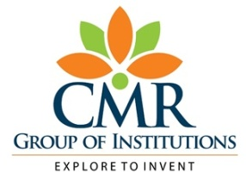

CMR INSTITUTE OF TECHNOLOGY
Kandlakoya(V), Medchal Road, Hyderabad – 501 401
Ph. No. 08418-222042, 22106 Fax No. 08418-222106

(2025-26)

CONTENTS

Sl. No. | Particulars | Page No.
 | Vision and Mission | 2
 | Syllabus | 4
 | Student Entry Behavior or Pre-requisites | 5
 | Course Outcomes | 6
 | Mapping of Course with PEOs-POs | 7
 | Mapping Of Course Outcomes with POs | 9
 | Direct Course Assessment | 10
 | Indirect Course Assessment | 11
 | Overall Course Assessment and Attainment level | 13
 | Pi diagrams, Bar charts, Histograms for representing results | 14
 | Lesson/Course Plan | 15
 | Programs | 16

- Vision and Mission

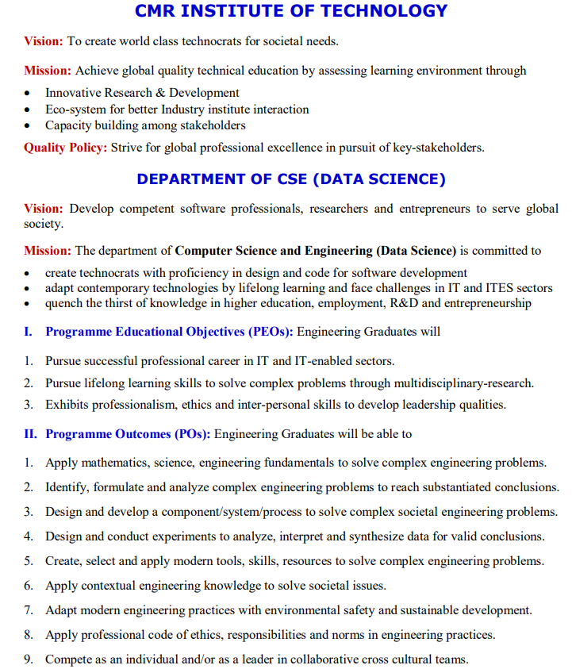

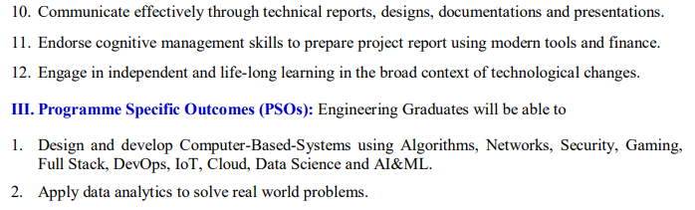

2.Syllabus
Devops LAB

Course | B.Tech.-VI-Sem. | L | T | P | C
Course Code | 22CDPC66 | - | - | 2 | 1
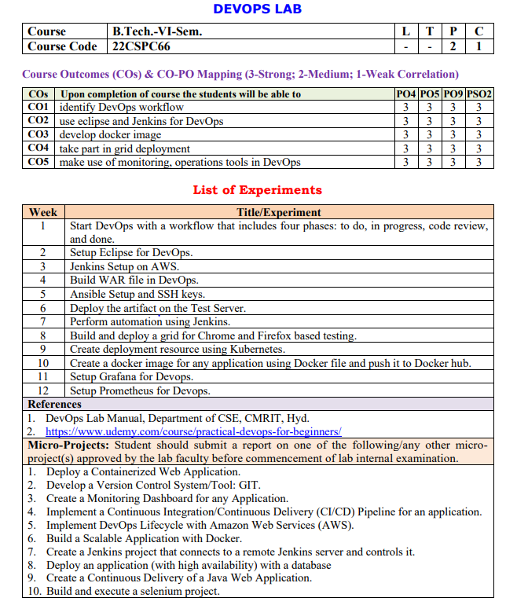

3.Student Entry Behavior or Pre-requisites

- Students should have basic knowledge on Linux commands
- Students should have basic knowledge on basic programming.
- Student should have knowledge on software engineering concepts
- These prerequisites are taken by the students during the first two years. However during the initial sessions the topics are reviewed.

4.Course Outcomes

Course Outcome | Course Outcome Statements
CO - 1 | identify DevOps workflow
CO – 2 | use eclipse for DevOps
CO – 3 | develop docker image
CO – 4 | take part in grid deployment
CO – 5 | make use of Jenkins framework in DevOps

5.Mapping of Course with PEOs-POs

(Only Ticking)

Program Educational Objectives (PEOs)

Sl. No. | PEOs Name | Program Education Objective Statements
1 | PEO - 1 | Pursue successful professional career in IT and IT-enabled sectors. [PO’s: 1,2,3,4,5,7,8,9,10,11 and 12] [PSO’s: 1 and 2]
2 | PEO – 2 | Pursue lifelong learning skills to solve complex problems through multidisciplinary-research. [PO’s: 1,2,3,4,5,6,7,8,9,10 and 12] [PSO’s: 1, 2 ]
3 | PEO – 3 | Exhibits professionalism, ethics and inter-personal skills to develop leadership qualities. [PO’s: 1,2,3,4,5,6,7,8,9,10,11 and 12] [PSO’s: 2 ]

Program Outcomes (POs)

PO Name | Graduate Attributes | PO Statements
PO1 | Engineering knowledge | Apply mathematics, science, engineering fundamentals to solve complex engineering problems. [PEO’s: 1,2 and 3] [PSO’s: 1,2 ]
PO 2 | Problem analysis | Identify, formulate and analyze complex engineering problems to reach substantiated conclusions. [PEO’s: 1,2 and 3] [PSO’s: 1,2 ]
PO 3 | Design/ development of solutions | Design and develop a component/system/process to solve complex societal engineering problems. [PEO’s: 1,2 and 3] [PSO’s: 1,2]
PO 4 | Conduct investigations of complex problems | Design and conduct experiments to analyze, interpret and synthesize data for valid conclusions. [PEO’s: 1,2 and 3] [PSO’s: 1,2 ]
PO 5 | Modern tool usage | Create, select and apply modern tools, skills, resources to solve complex engineering problems. [PEO’s: 1,2 and 3] [PSO’s: 1,2 ]
PO 6 | The engineer and society | Apply contextual engineering knowledge to solve societal issues. [PEO’s: 2 and 3]
PO 7 | Environment and sustainability | Adapt modern engineering practices with environmental safety and sustainable development. [PEO’s: 1,2 and 3]
PO 8 | Ethics | Apply professional code of ethics, responsibilities and norms in engineering practices. [PEO’s: 1,2 and 3] [PSO’s: 2 ]
PO 9 | Individual and team work | Compete as an individual and/or as a leader in collaborative cross cultural teams. [PEO’s: 1,2 and 3]
PO 10 | Communication | Communicate effectively through technical reports, designs, documentations and presentations. [PEO’s: 1,2 and 3] [PSO’s: 2 ]
PO 11 | Project management and finance | Endorse cognitive management skills to prepare project report using modern tools and finance. [PEO’s: 1 and 3] [PSO’s: 2]
PO 12 | Life-long learning | Engage in independent and life-long learning in the broad context of technological changes. [PEO’s: 1,2 and 3] [PSO’s: 1,2 ]

6.Mapping Of Course Outcomes With POs

No | Course Outcomes | Po₁ | Po₂ | Po₃ | Po₄ | Po₅ | Po₆ | Po₇ | Po₈ | Po₉ | Po₁₀ | Po₁₁ | Po₁₂ | Avg
1 | CO - 1 |  |  |  | 3 | 3 |  |  |  | 3
2 | CO – 2 |  |  |  | 3 | 3 |  |  |  | 3
3 | CO – 3 |  |  |  | 3 | 3 |  |  |  | 3
4 | CO – 4 |  |  |  | 3 | 3 |  |  |  | 3
5 | CO – 5 |  |  |  | 3 | 3 |  |  |  | 3
 | Avg |  |  |  | 3 | 3 |  |  |  | 3

7.Direct Course Assessment

(As mentioned in following table of 10 parameters, of which consider only the parameters required for this courses)

No | Description | Targeted Performance | Actual Performance | Remarks | Course Attainment
1 | Internal Marks(25) | 80% of Students(182 Students) should Secure 60% of Internal Marks i.e., 15 Marks
2 | External Marks(50) | 80% of Students(182 Students) should Secure 70% of External Marks i.e., 35 Marks
3 | Clearing of Subject | A minimum of 95% of Students(216 Students) should clear this course in first attempt
4 | Getting First Class | 90% of Students(205 Students) should Secure I Class Marks i.e., 45 Marks in my course
5 | Distinction | 80% of Students (182 Students) should secure First Class With Distinction i.e., 53 Marks in my course
6 | Outstanding Performance | 60% of Students (137 Students) should secure 80% and above Marks. i.e., 60 Marks in my course

8.Indirect Course Assessment

(As mentioned-strong (3), moderate (2), weak (1) & no comment (0))

Mission Statement of CSE
- Impart fundamentals through state of art technologies for research and career in Computer Science & Engineering(DS).
- Create value-based, socially committed professionals for anticipating and satisfying fast changing societal requirements.
- Foster continuous self learning abilities through regular interaction with various stake holders for holistic development.

Correlation of Mission Elements with Mission Statement of CSE(DS) Department related to the Course (only Ticking given by faculty)

No | Mission Elements | Strong | Moderate | Weak | No Comment
M-1 | Impart Fundamentals | √
M-2 | State Of Art Technologies | √
M-3 | Research & Career Development | √
M-4 | Value based Socially Committed Professional | √
M-5 | Anticipating & Satisfying Industry Trends |  | √
M-6 | Changing Societal Requirements |  |  | √
M-7 | Foster Continuous Learning | √
M-8 | Self Learning Abilities | √
M-9 | Interaction with stakeholders | √
M-10 | Holistic Development |  | √

Indirect Course Assessment through Student Satisfaction Survey
(Note for *: Parameters used for course teaching like
a: Classroom teaching b: Simulations c:labs d: Mini_Projects
e: Major Projects f: Conferences g: professional activities
h: Technical Clubs i: Guest Lectures j: Workshops k: Technical Fests l:Tutorials m:NPTLs n:Digital Library o: Industrial Visits p: software Tools q: Internship/training r:Technical Seminars
s: NSS t: NSS u: sports etc.
No | Question Based on PEO/ PO/PSO/CO | Parameters  (a /b /c…/)* | Strong (3) | Moderate (2) | Weak (1) | No comment (0)
1 | Did the course impart fundamentals through interactive learning and contribute to core competence?
2 | Did the course provide the required knowledge to foster continuous learning?
3 | Whether the syllabus content anticipates & satisfies the industry and societal needs?
4 | Whether the course focuses on value based education to be a socially committed professional?
5 | Rate the role of the facilitator in mentoring and promoting the self learning abilities to excel academically and professionally?
6 | Rate the methodology adopted and techniques used in teaching learning processes?
7 | Rate the course in applying sciences & engineering fundamentals in providing research based conclusions with the help of modern tools?
8 | Did the course have any scope to design, develop and test a system or component?
9 | Rate the scope of this course in addressing cultural, legal, health, environment and safety issues?
10 | Scope of applying management fundamentals to demonstrate effective technical project presentations & report writing?
 | Total
 | Average
Total Average
9.Overall Course Assessment

(80% Direct + 20% Indirect, if any)

No | Assessment Type | Weightage | Attainment Level
1 | Direct-Assignment, Quiz, Subjective, University Exams, Results, Bench Marks | 0.8
2 | Indirect-Surveys-Questionnaire | 0.2
 | Overall

DEVOPS LAB Course Attainment level:

10.Pi diagrams, Bar charts, Histograms

(For representing previous results, if any)

ICS Pass % for Last 4 Academic Years | Appeared | Passed | Pass%

11.Lesson/Course Plan

Week No. | Name of the Program | Week | Text Books | Mode of Assessment
1 | Start DevOps with a workflow that includes four phases: to do, in progress, code review, and done | 1 | R1 | By observations, lab records, viva-voice
2 | Setup Eclipse for DevOps. | 2 | R1 | By observations, lab records, viva
3 | Jenkins Setup on AWS. | 3 | R1 | By observations, lab records, viva
4 | Build WAR file in DevOps. | 4 | R1 | By observations, lab records, viva
5 | Ansible Setup and SSH keys. | 5 | R1 | By observations, lab records, viva
6 | Deploy the artifact on the Test Server. | 6 | R1 | By observations, lab records, viva
7 | Perform automation using Jenkins. | 7 | R1 | By observations, lab records, viva
8 | Build and deploy a grid for Chrome and Firefox based testing. | 8 | R1 | By observations, lab records, viva
9 | Create deployment resource using Kubernetes. | 9 | R1 | By observations, lab records, viva
10 | Create a docker image for any application using Docker file and push it to Docker hub. | 10 | R1 | By observations, lab records, viva
11 | Setup Grafana for Devops. | 11 | R1 | By observations, lab records, viva
12 | Setup Prometheus for Devops. | 12 | R1 | By observations, lab records, viva

Experiment-5
(Note: All Blue Words is a command, just copy and paste)
Aim:Build War file in Devops
Require Software & Tools: Jenkins, Jdk-17 or jdk-21, Git bash.
Procedure:
Step-1: First open any browser and Search download Jenkins -> click on first link -> scroll down and click on windows logo -> download will be started.
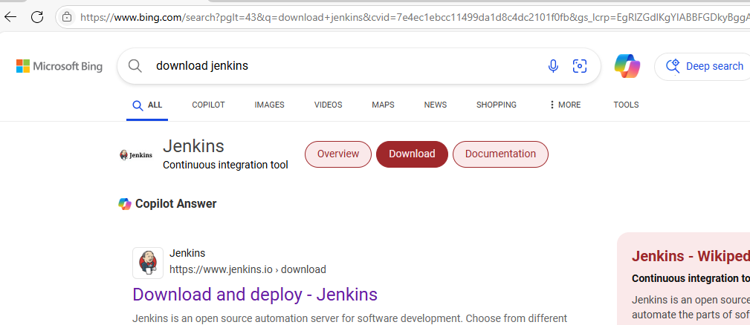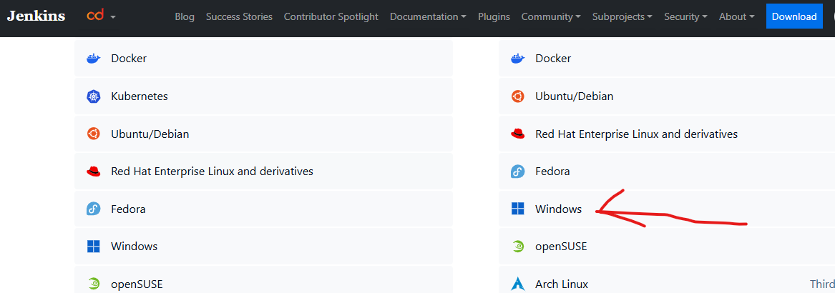

Step2: First check java jdk in your system, if java is available check the java version using cmd. otherwise download and install jdk-17.
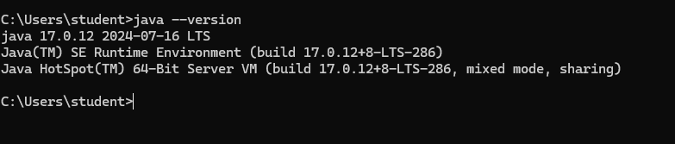

Step-3: Download Git Bash 64-bit Standalone Installer, and install git bash in your system. After installation set the git.exe path in your runtime environment.

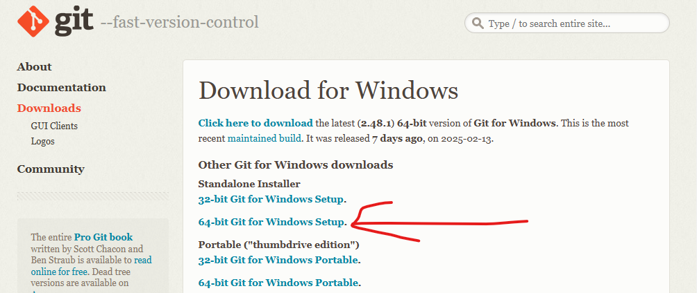

Step-4: Now install Jenkins in your system -> click on next and again next -> select run service as a local system -> click on next and click on Test port -> click on next and click on change and set the java jdk path -> click on next and again next and click on install.

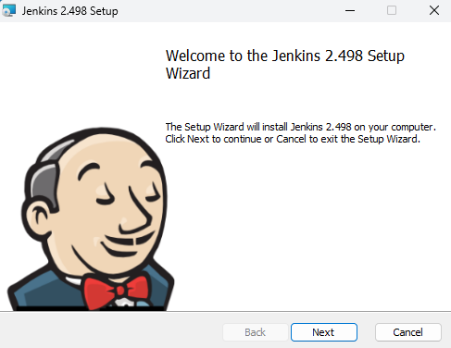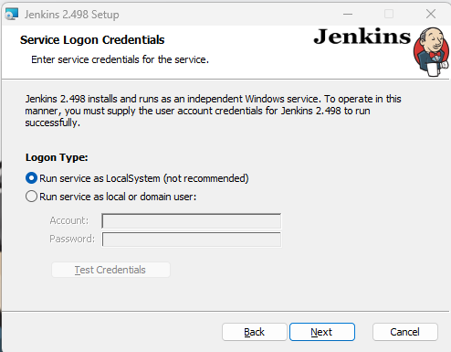

Step-5: After that install Git Bash in your system (no need to change anything just click on next next and next till last).

Step-6: Now open a browser -> search localhost:8080

Step-7: It will open your Jenkins server -> Copy red line location and search it to in your File manager.

Step-7: It will show open with option just select notepad -> after that copy the password and paste in Jenkins server -> click on continue -> click on suggested plugin -> it will take some time for installation -> create admin user using given details and click on save and continue -> after that click on save and finish -> Click on start using jenkins It will show Jenkins Dashboard.

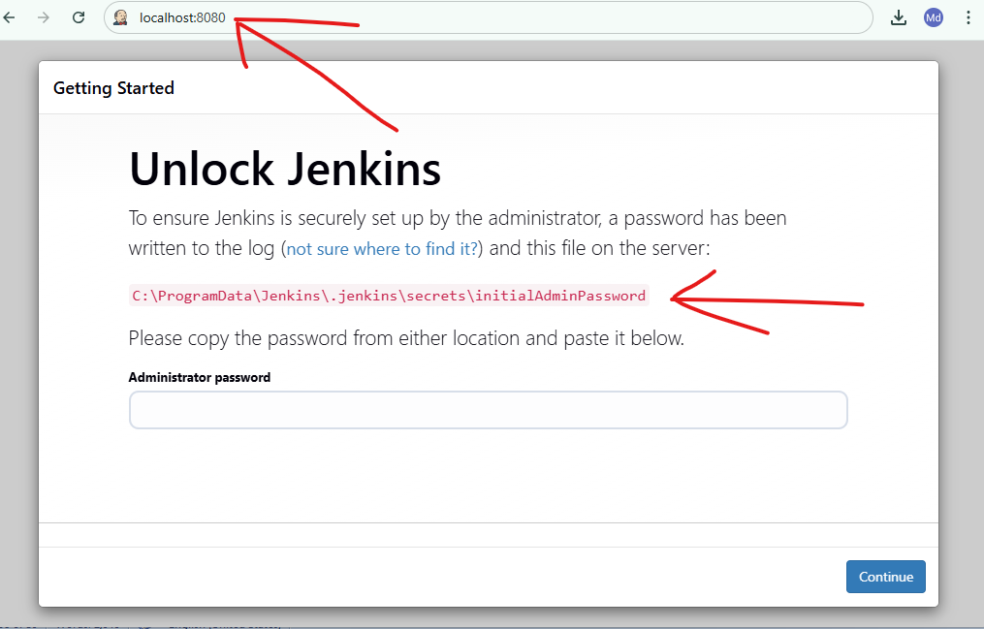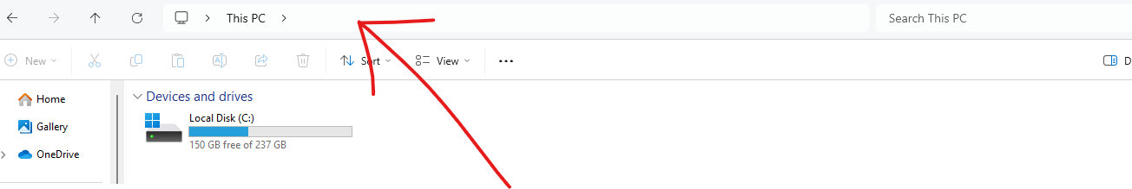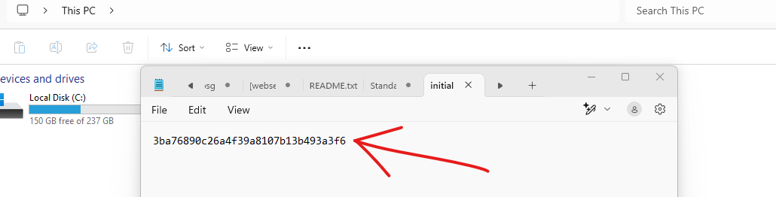

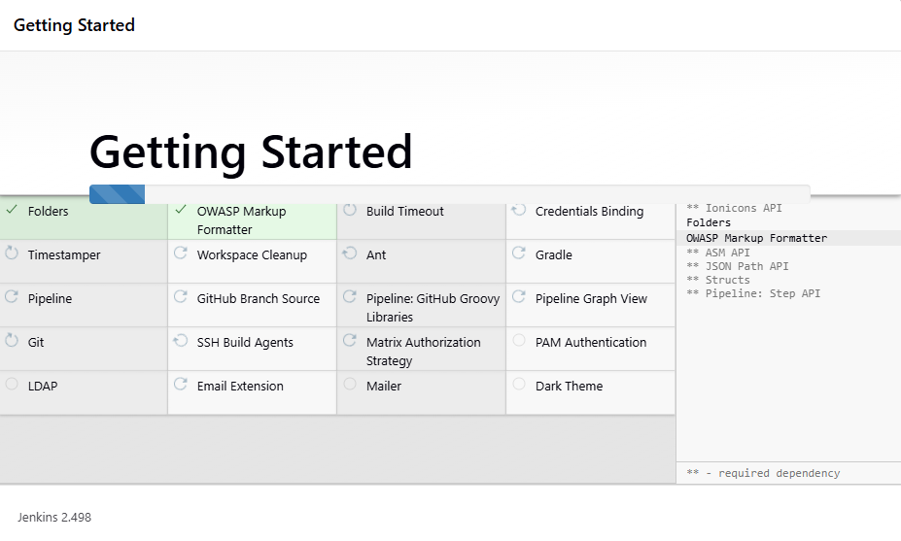

Step-8: After that click on manage Jenkins -> click on plugin -> click on available plugin -> search maven -> select maven integration -> click on install -> scroll down and check maven integration and and loading plugin is green and success or not -> After success click on go back to the top page

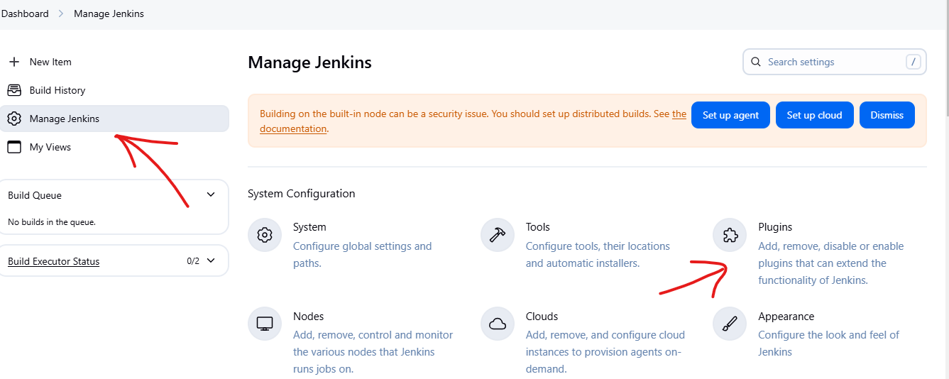

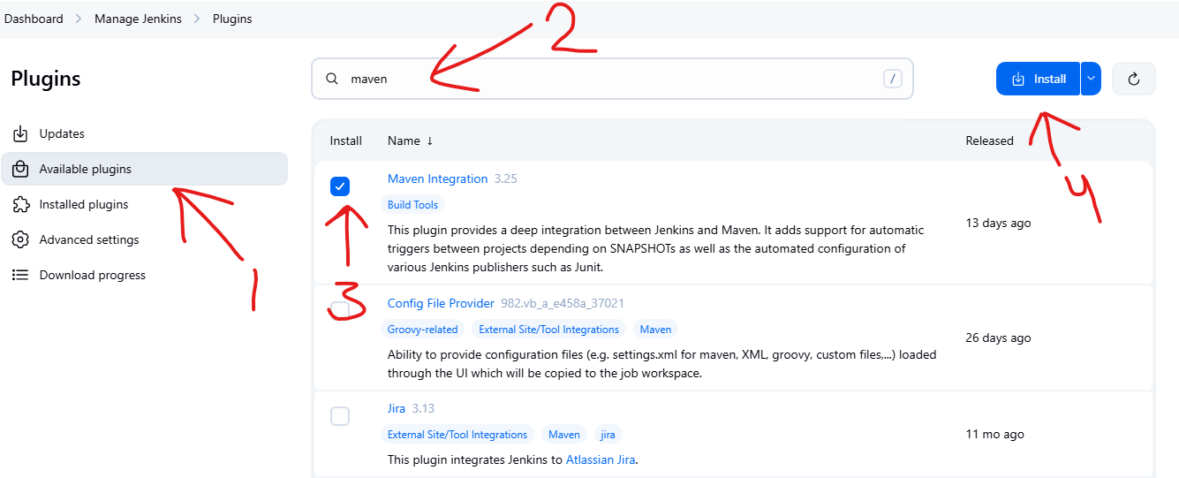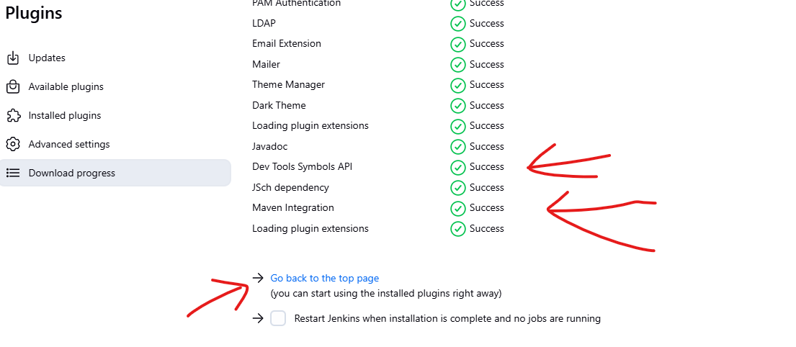

Step-9: Now again click on Manage Jenkins -> click on tools -> scroll down and check Git path -> after that scroll down and in a Maven installation section -> click on add maven -> write maven name and click on apply -> click on save.

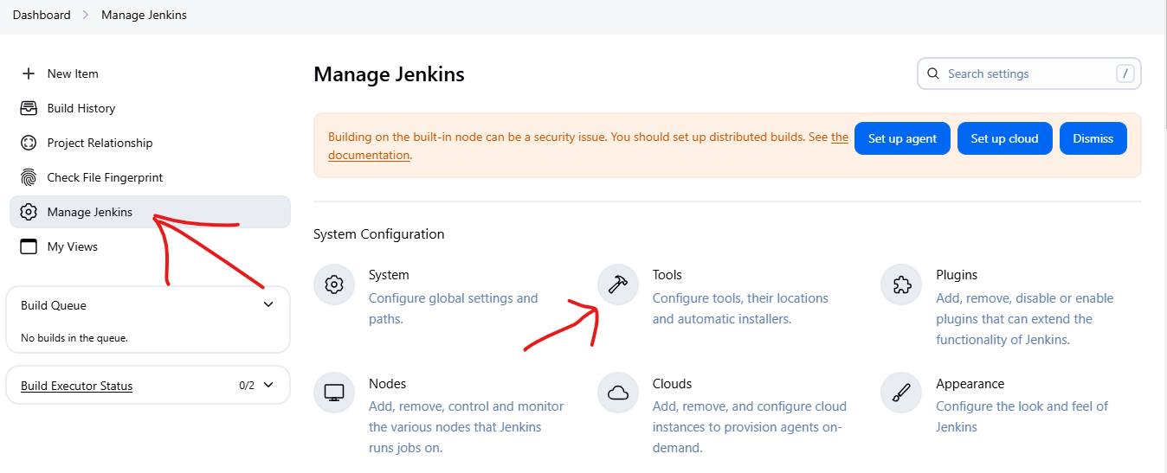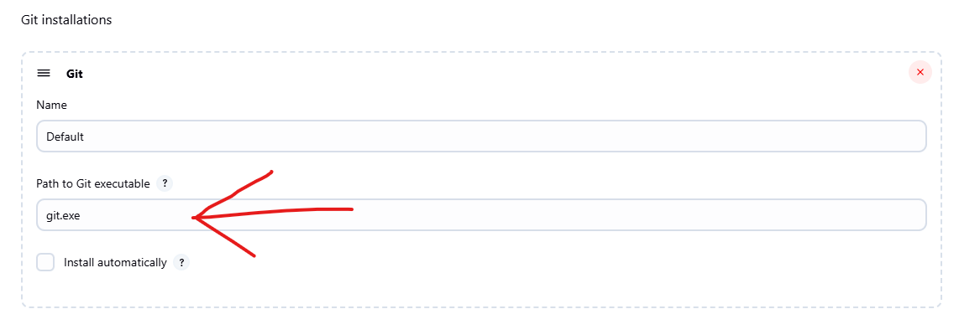

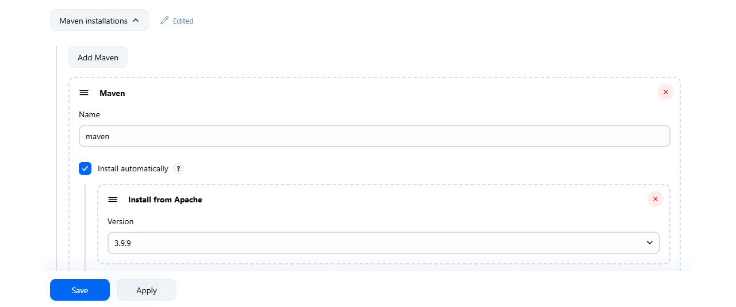

Step-10: now click on dashboard -> click on create a job -> type your buildwar name (i.e. myWar) -> select Maven Project -> click on OK

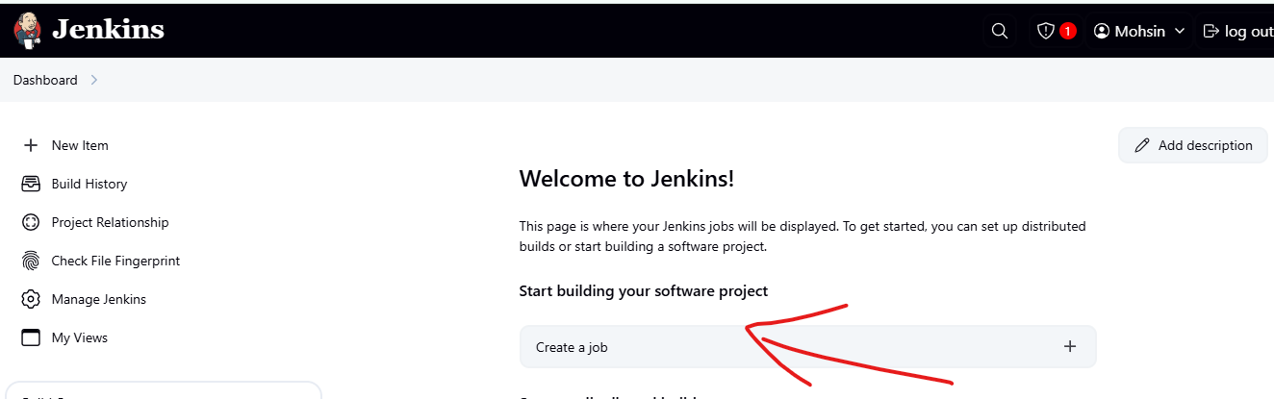
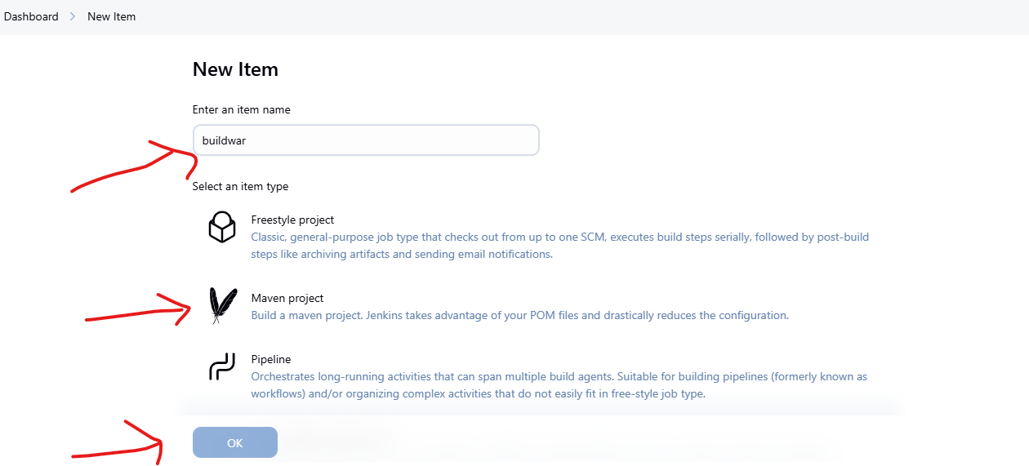

Step-10: Now take a new page -> login your GitHub -> check second experiment repository like Devops_pipeline -> copy the git link of second experiment.

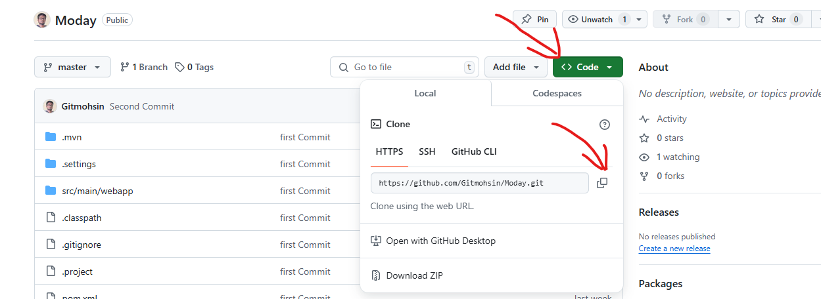

Step-11: scroll down and go to Source code management section -> select git -> paste git link -> scroll down go to build option and type clean install package in goals option -> click on apply -> click on save.

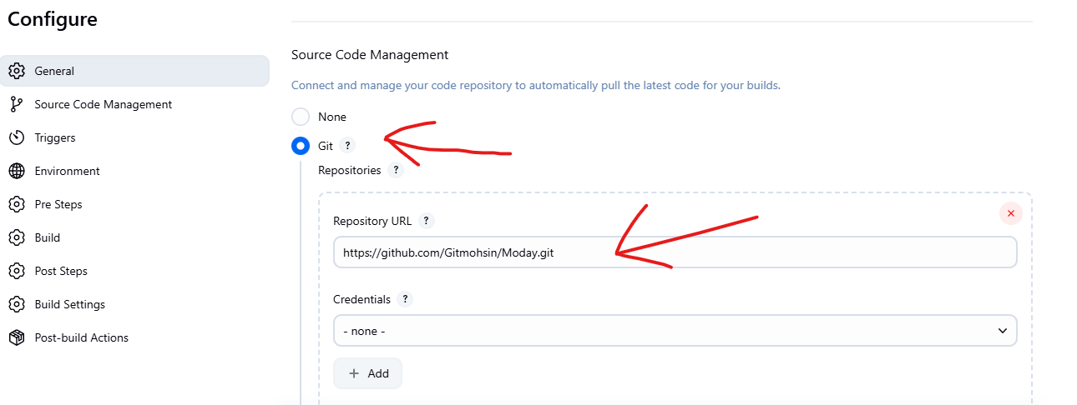

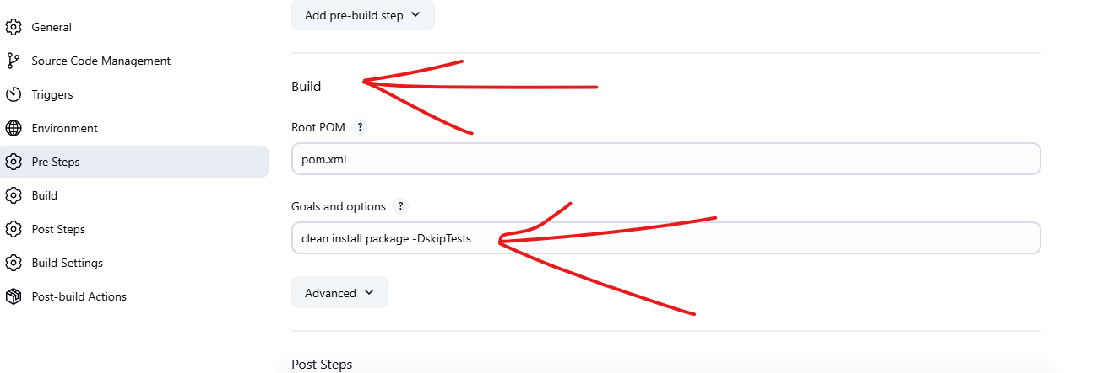

Step-12: After save the file -> it will show an option in left side build now -> click on build now -> It will take two to five minute for creating build file.

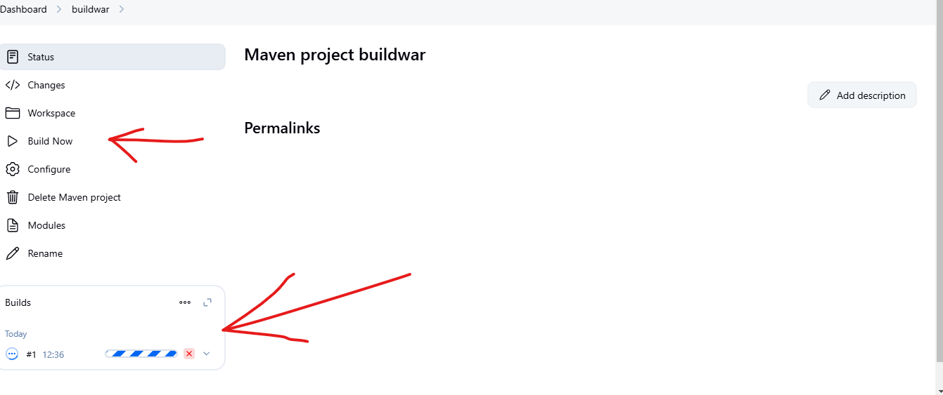

Step-12: After building it will show success with green mark -> click on that section -> it will open new section -> click on console output -> scroll down and check status, build success or not.

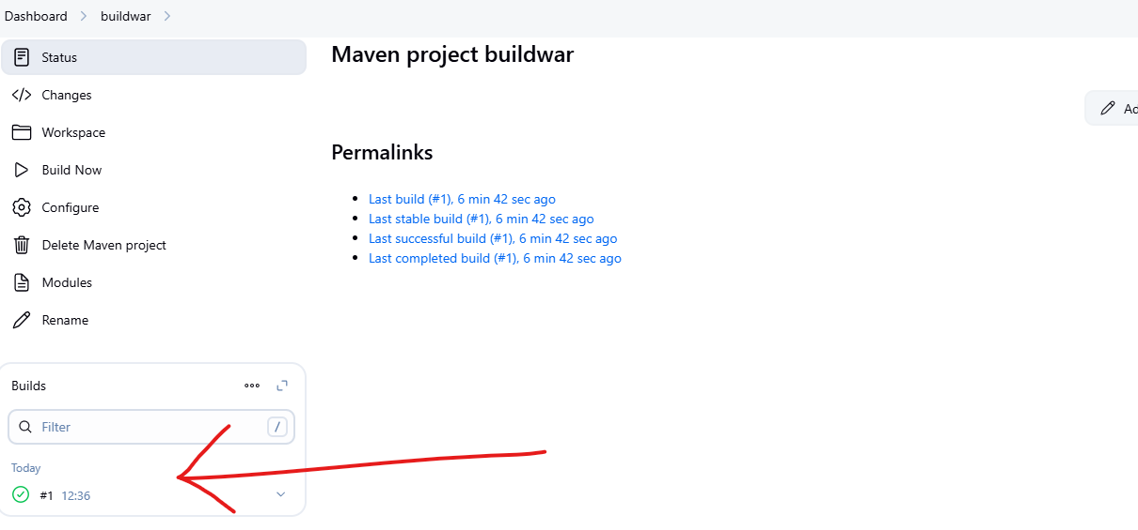

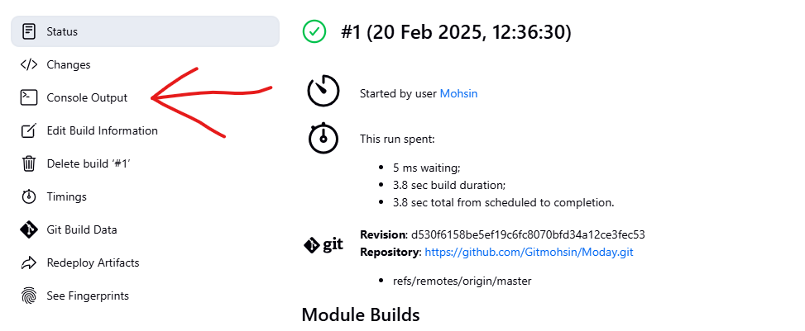

Output:-
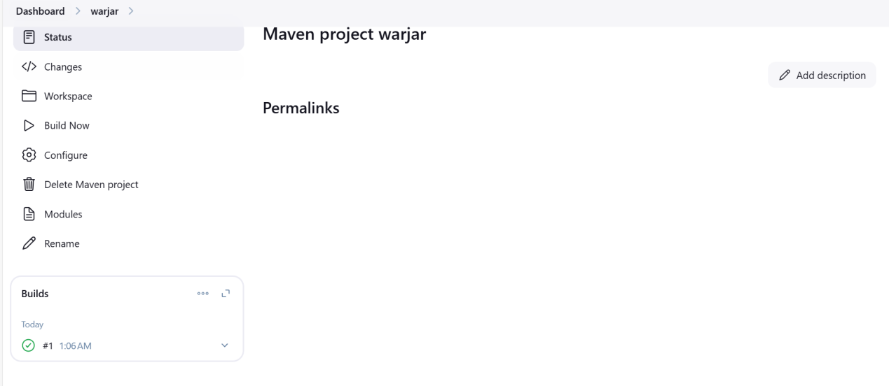
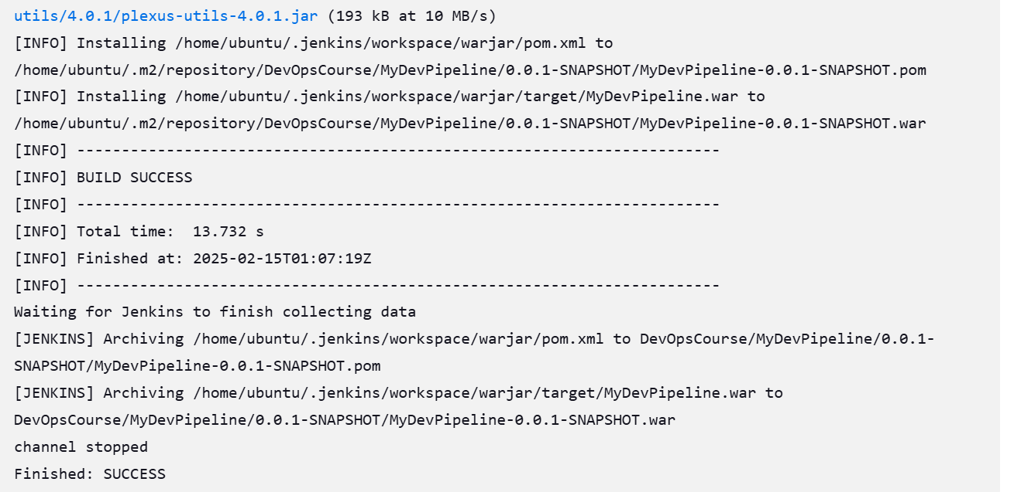

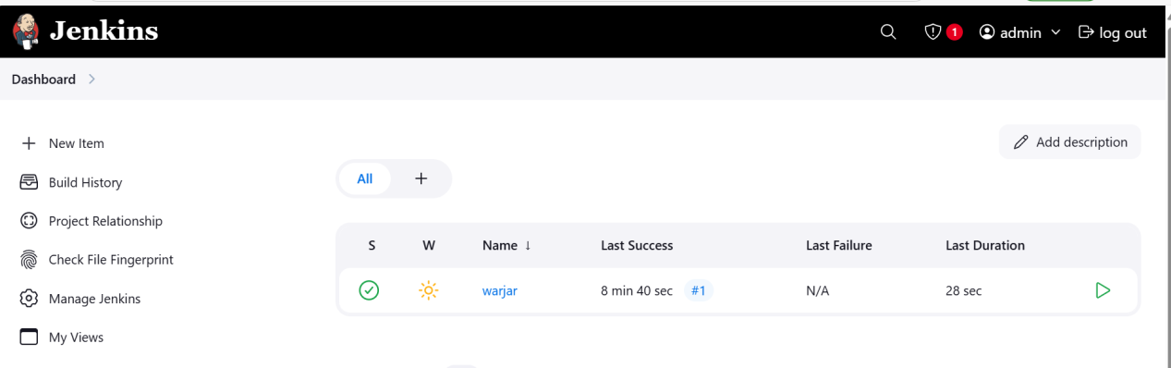

Experiment 11
Aim:-Setup Grafana for Devops.

ACCESS GRAFANA :

kubectl get secret prometheus-grafana -n monitoring -o jsonpath="{.data.admin-user}" | base64 --decode ; echo

If you run the above command u can see the username for grafana (admin)

kubectl get secret prometheus-grafana -n monitoring -o jsonpath="{.data.admin-password}" | base64 --decode ; echo

If you run the abvoe command u can see the password for grafana (prom-operator)

PORT FORWARDING

kubectl port-forward svc/prometheus-grafana 3000:80 -n monitoring

Click on the web preview give the port no 3000 and click on change and preview u can see the grafana

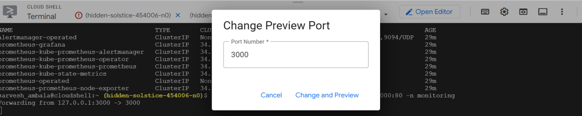

Output:-

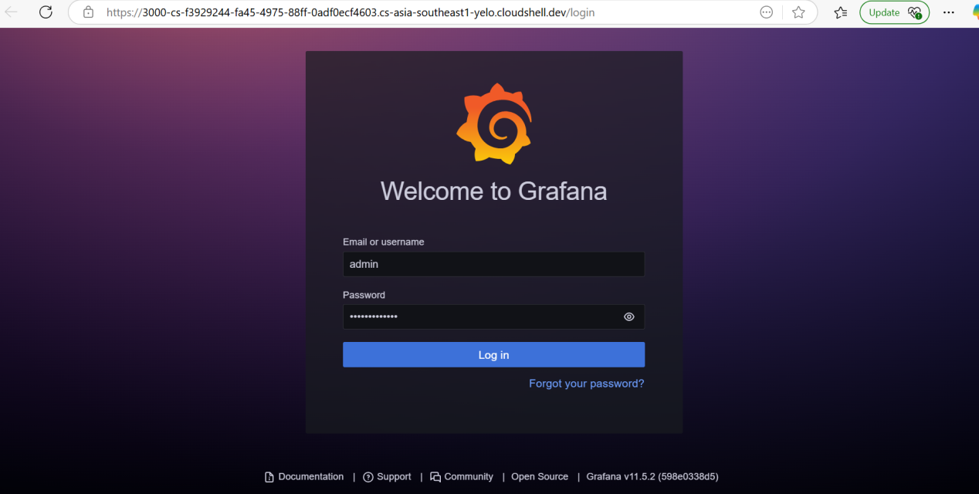

You can login with admin and prom-operator

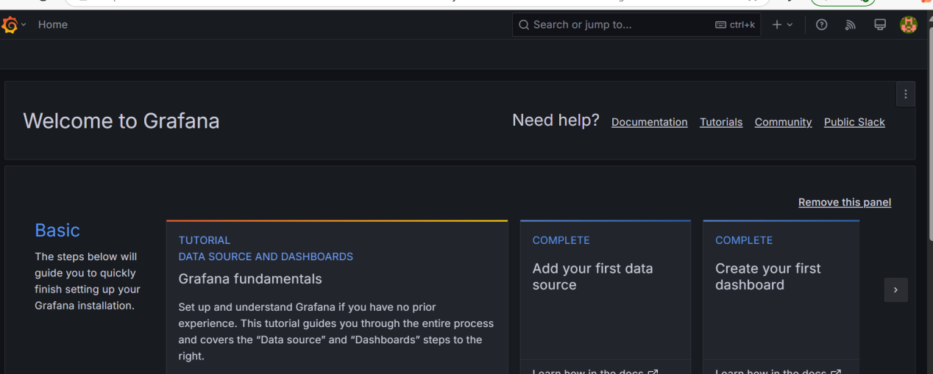

Experiment 12

Aim:-Setup Prometheus for Devops.

PROMETHEUS SETUP:

helm repo add prometheus https://prometheus-community.github.io/helm-charts

helm repo update

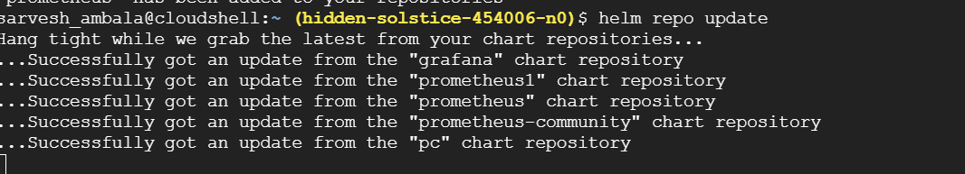

helm install prometheus prometheus-community/kube-prometheus-stack --namespace monitoring --create-namespace

This will install prometheus,alermanager and grafana

Check the prometheus pods and services

kubectl get pods -n monitoring

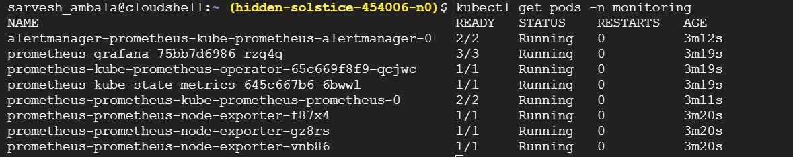

kubectl get svc -n monitoring

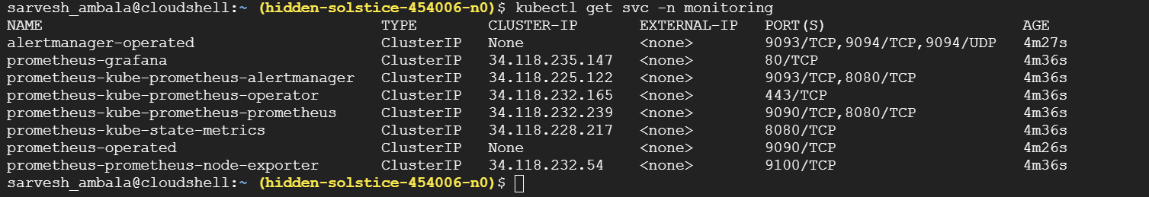

Access prometheus and port forwarding

kubectl port-forward svc/prometheus-kube-prometheus-prometheus 9090:9090 -n monitoring

Click on the webpreview

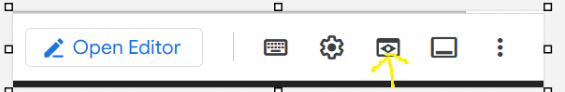

Change port no to 9090

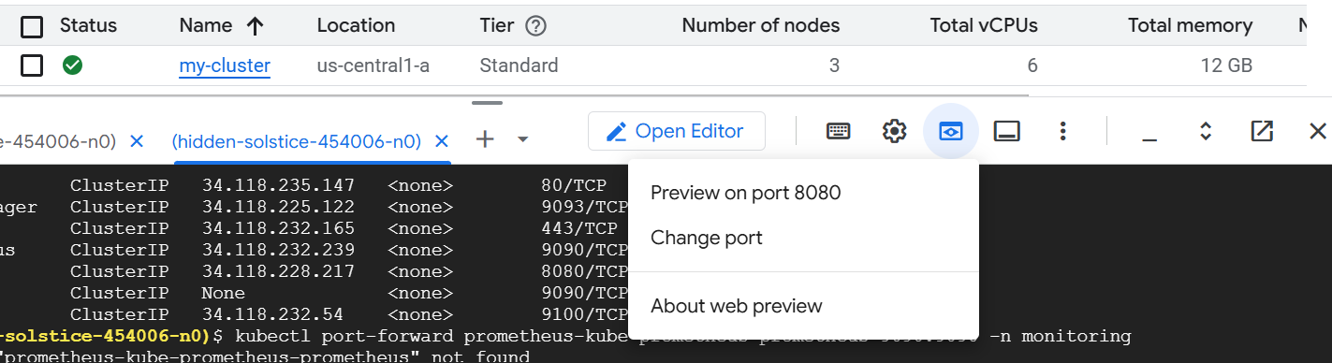

Click on change and preview

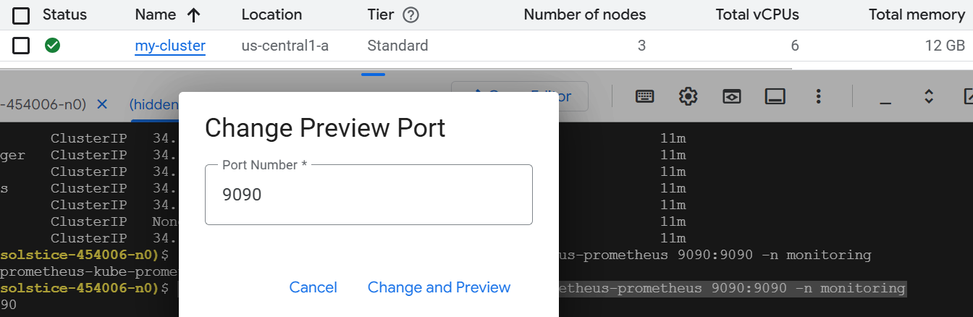

Now u can able to see prometheus in the browser

Output:-

